The Benefits of Training Cooperative Behaviors for Ageing Animals, A Whole Life Approach
March 2022
Debra Marrin, Dr. Bethany Krebs
San Francisco Zoo and Gardens
Approaches to training animals with specific needs
Positive reinforcement training is an essential component in a holistic approach to animal management. It is a powerful tool to help ensure positive welfare for animals at every life stage. For ageing animals, the benefits of positive reinforcement training increase when the animals experience age related health issues. Caregivers and veterinarians want to find ways to ease pain in arthritic joints, treat kidney disease, spondylosis, diabetes, vision loss, and other ailments associated with aging (Dennis, 2013). Caregivers may also need to address dental disease, overgrown claws and hooves, urine soiled fur, and the animal’s inability to groom itself properly. In order to diagnose and treat age-related issues in the safest and least stressful manner we need to utilize a variety of voluntary medical and husbandry behaviors. Many voluntary behaviors useful in old age can be equally useful through all life stages, such as voluntary hand injection, weighing, hoof care, ultrasound, and blood draws.
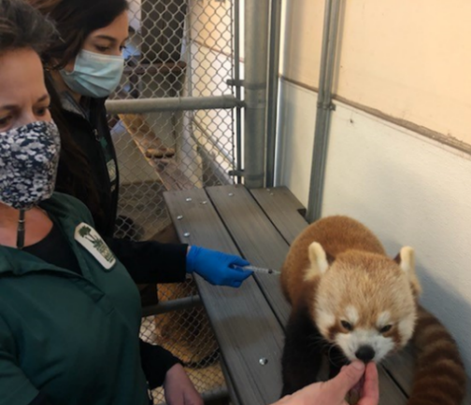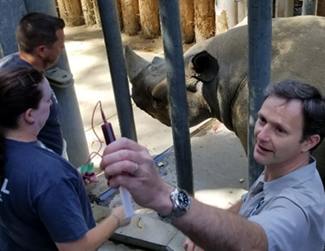

Age related behavior changes
When training ageing animals, the scientific principles and techniques we use for training do not change. How we assess behavior and develop a behavior plan also remains the same. What may change are the animal’s physical and mental abilities. Behaviors the animals could easily perform in the past may become behaviors they are physically incapable of performing. Many issues may prevent the animal from participating in training. Some behaviors may cause so much pain that they refuse them because the avoidance of pain is a far greater motivator than the reinforcers we may offer. Mental faculties may diminish with age making it more difficult for the animals to learn new behaviors. Participation in established or new behaviors may not occur during periods of unresponsiveness to their environment caused by age related cognitive decline. Medications prescribed for pain management may also affect mental capacities and physical abilities. Caregivers may find it challenging to provide physical comfort without hindering mental and physical capacities if such pain medications become necessary. A lack of mental alertness may prevent training from occurring at certain times of day or on days that are bad overall for the animal. The responsibility of trainers is to make choosing the “right” behavior easy for the ageing animal whenever possible. Trainers can observe how medications affect the animal’s behavior at different times of day and plan sessions accordingly. Asking the animal to participate when it is physically comfortable, and capable, and mentally alert will create the most optimal conditions to make compliance easy for the animal. For example, an animal receiving medication to treat arthritis pain should be given the medication and time for the medication to take effect before the trainer asks the animal to shift or participate in other behaviors.

Each animal is an individual
All animals age and they do it in different ways. As each animal ages it will experience a unique combination of progressive age-related changes. Changes in physical and cognitive abilities often lead to needed changes in behavior management. Each animal should be assessed, and managed with a customized plan based on his or her physical, psychological, and health challenges. Behavior goals should be set with input from multiple team members including keepers, curators, veterinary staff, and behaviorists (Watters et al., 2015). Ongoing welfare and health assessments will pinpoint diagnostic and treatment needs, which will help guide training goals.
As the animal’s needs change, caretakers or veterinary staff may ask for new trained behaviors to optimize care. Staffs should be encouraged to think outside the box and train novel behaviors in addition to the traditional repertoire. Being open minded and trying new ideas is how we progress our quality of care. Many treatments, diagnostic procedures or therapies can be candidates for training, such as physical therapy, blood pressure readings, ultrasounds, acceptance of sub-cutaneous fluids, acupuncture, laser therapy, and other non-traditional treatments. Appropriate diagnosis, treatment, and management of age-related issues are best accomplished through teaching our animals to be active participants in their care.
Every animals’ training and care needs should be considered on a case-by-case basis. Nonetheless, there are general factors to consider when deciding when, how, and what behaviors to train to help care for the specific needs of ageing animals. Safety concerns, characteristics of the animal, the diagnostics or treatments needed, the behavior required to succeed at the diagnostics or treatment, and the human-animal relationship will all help determine the best approach for an individual.
Animal Safety
Voluntary participation on the animal’s part improves safety for both the animal and the staff. This is true at all life stages, but as animals age risks may increase for the animal. Older animals may not handle anesthesia as well (Carpenter, Pettifer, & Tranquilli, 2005; Hughes, 2008) or may be more easily injured during restraint due to decreased bone densities or other age related changes (Navaratnarajah & Jackson, 2013) . Therefore, the voluntary behaviors that increase diagnosis and treatment options also increase safety. Voluntary participation in their health care additionally reduces or eliminates the stress an animal may experience when forced treatments take away all choice and control (Herron & Shreyer, 2014; Yin, 2009). Stress may have significant negative impact on an aged animal’s overall welfare, as they may not bounce back as quickly from negative experiences (Kirkland, Stout, & Sierra, 2016). With a probable increase in medical issues due to ageing, staff can prevent animals from experiencing negative experiences through training cooperative behaviors. Keeping interactions positive between animals and humans will also reduce fight and flight behavior that can cause unsafe situations for both animals and staff.
Fine-tuning some medication dosages to reach the optimal amount is only possible in many cases with the use of voluntary medical behaviors. Behaviors such as blood pressure monitoring and blood draw are important to evaluate the effectiveness of medications. For instance, anesthesia can significantly alter animals’ blood pressure or hematological parameters (Boström et al. 2002, Gaynor et al. 1999), making it difficult to determine whether a medication is having the desired effect without voluntary participation of the animal under treatment. Veterinarians can better determine if the medication dose is having the desired effect when the animal is not anesthetized during testing. Anesthesia comes with risks and should be used only when necessary making it a poor choice for regular repeated diagnostics.

Whole life training
Early training in an animal’s life establishes a foundation of behaviors that help them to participate voluntarily in their own health care. It provides veterinary and animal care staff options for diagnosis and treatments that would not be possible otherwise. Already established behaviors provide instant options for veterinarians and animal staff caring for ageing animals as new challenges arise. When new cooperative behaviors are needed, animals with an established learning history will learn new behaviors more quickly, making novel diagnostics or behaviors achievable sooner. New behaviors may be mastered in a much shorter time than if the animal has no training history, and foundational behaviors already established provide a shorter path to a new behavior goal. For example, a cat or great ape previously trained for voluntary blood draws may learn a new behavior to allow blood pressure readings within days or weeks instead of months. By prioritizing training throughout animals’ lives, we can set the stage for optimal care and well-being as they age.
Planning considerations
Veterinary staffs should play a pivotal role in setting behavior goals. They can advise the animal care and training team on which behaviors would be most beneficial for the individual animal to learn. Once the goals are set the vet staff should also inform the trainers what the animal will be required to do, for how long, and under what conditions. In order for a procedure to be successful the trainers and animals need to practice as closely as possible what they will need to do when the behavior is utilized. Trainers need to know what time of day it will occur, who will be doing the procedure, how many people will be involved, what equipment will be used, or if the equipment makes noise or has flashing lights. Trainers will also need to understand how long the vet needs the animal to remain in position, what type of preparation may be needed like shaving hair or fur, applying alcohol or gel, or whether the animal can eat before and during the procedure. Frequency of training sessions will likely be informed by knowing how often the behavior will be needed (e.g. daily or monthly?). In a best-case scenario, the people who will be involved the day of the procedure will be part of the training picture as early and often as possible. This may necessitate including veterinary staff in training sessions regularly. Introducing animals to new people and teaching them to be flexible throughout their life will benefit them when teaching and utilizing medical behaviors. The time and effort invested in positive relationships and voluntary medical behaviors will make it easier for staff to support positive welfare for ageing animals.
Long term planning
Training a novel behavior is only part of what the staff need to consider. Behaviors need to be maintained to remain reliable for future use. Part of the discussion amongst team members should include how frequently the behavior will need to be utilized. This may be informed by the individual’s need for veterinary care, pain management, or other husbandry considerations. Once the trainers know how frequently a behavior will be needed, they can set a training schedule that will maintain the behavior. The training and maintenance of every behavior is a “study of one”. Every animal is unique and will perform differently during training, so the training and maintenance plans should be customized for the individual. A cooperative behavior needed frequently (e.g. every three days) may dictate a need to increase the time dedicated to training and maintenance in order to keep behavior reliable, especially for behaviors that may cause pain or discomfort to the animal. For example, a Sumatran tiger diagnosed with cancer needed weekly injections and monthly blood draws. In order to keep the behaviors positive, the animal was trained daily so the number of sessions without a needle insertion remained higher than the sessions with a needle insertion. This strategy kept participation in the behavior reliable and positive for the tiger throughout his treatment.
Diets may also need to be adjusted so that high value reinforcers are used strategically for procedure days. A nutritionist can be helpful in setting healthy diets that support training goals. In some cases, the animal may receive more food reinforcers than is optimal within their diet, but the training benefits may outweigh the diet concerns. In other cases, it may just be a matter of rearranging when the preferred diet items are used.
Human -animal relationships
An important component of training at every age is developing a positive trusting relationship between caregivers and the animals (Pryor 2002; Zeligs 2014; Marrin, Poole, Krebs, & McIntyre, 2019). The stronger the relationship between human and animal the more likely the animal will participate voluntarily when it does not find food motivating, which can be likely if an animal falls ill (Ashley & Wingfield, 2011). Relationship strength may also be the difference between success and failure when new stimuli are added to the environment. A good trainer will have developed a positive relationship with their animals, and taught them that new stimuli and people are associated with positive outcomes.
Human- animal communication should be two way
The trainer’s ability to see the environment from the animal’s perspective, and empathize will help them to be flexible and open-minded teachers. It is the trainer’s responsibility to observe their animal’s behavior, and adjust antecedents (i.e. the events, actions, and circumstances that occur immediately before a behavior) and behavioral criteria accordingly so the animal can easily make the right choice to perform needed behaviors. Behavior is not stagnant and as the animals age behavior changes may be due to changes in physical and mental health issues that make previous reliable behaviors more difficult to perform (Chiu & Bodley, 2010; Krebs et al. 2018). Competing motivators may be the cause when there is a change in compliance with once reliable cues. The animal may refuse a specific behavior because the motivation to avoid pain associated with doing the behavior may be stronger than the motivation to acquire food or other reinforcers the trainer may offer (LaGraize, Borzan, Rinker, Kopp, & Fuchs, 2004). Another possibility is a change in cognitive function that affects the animal’s behavior (Azkona et al., 2009; Bellows et al., 2016; Peters et al., 1996).
Zoo animals living in a protected environment with their physical, emotional, and medical needs taken care of may survive far longer than their wild counterparts. These extended life spans may lead to health issues unique to older animals, including issues which would likely lead to death in animals not in human care. Zoos with a cradle to grave approach therefore find the need for training and maintaining voluntary medical and husbandry behaviors an essential component to maintaining positive welfare. Adding new behaviors to training programs that eventually become standard practice helps to raise the bar for best practices industry wide. Managers need to set their staffs and animals up to succeed to provide the animals the best care and quality of life possible. This can be accomplished by considering what possible age-related factors may affect the animal’s behavior.
A physical or mental change in the animal may lead to behavior changes during training. A refusal to perform a behavior is information to the trainer, veterinarian, or care staff. Animals who have participated reliably for years in voluntary husbandry and medical behaviors may suddenly refuse to respond to cues that previously elicited their participation. If we can determine the cause of the change, we can adjust the environment and our expectations to achieve our training goals. Sometimes trainers blame the animal, or use descriptors such as lazy, vicious, or stubborn, labeling the animal and not the animal’s behavior. Labeling the animal is not beneficial to the evaluation and planning process. Instead, we need to do a functional assessment that considers the antecedents, observable behavior, and the consequences that follow. (Friedman 2007)
If you want to change behavior, change the environment
Declining strength or mobility is common in older animals and simple modifications to their training space can support positive training outcomes. Many common age-related changes in animal’s bodies can result in painful or limited ability to navigate a once accessible enclosure. Simple modifications such as additional handholds for primates can help them navigate their environment without pain. Tiered platforms, steps, and ramps, may help animals to be reliable with behaviors such as recall and securing. Voluntary medical behaviors rely on specific environmental conditions to make the goals possible. The diagnosis or treatment goals often rely on the ability to access specific body parts. Some animals may be trained in a free contact situation making it easy to access any body part for tests, treatments, or physical therapies. Animals that are trained in a protected contact scenario pose a greater challenge. Facility modifications may be needed such as blood sleeves, tail ports, ultrasound windows, or training benches. Facility modifications that are made for training should focus on animal comfort and human safety. (Marrin, Krebs, Watters 2018)

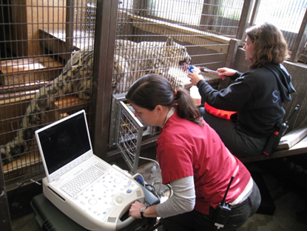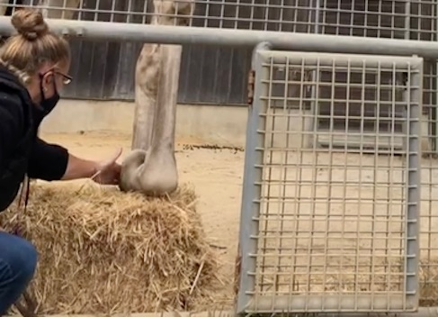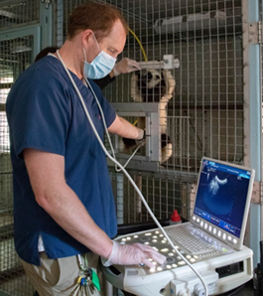
When new facilities are designed, providing appropriate training spaces should be a priority. Compiling a list of all of the behavior goals for the animals that will live in the environment can aide the design process. Older facilities not designed or built with training in mind can be successfully modified to allow for training; however, modifications after the build may be costlier, or worse, never added. Facility design or modifications will vary greatly depending on the species. In general, across all species the environment needs to be positive for the animal. A positive learning environment will set-up the learner and trainer to succeed.

Behavior speaks
Zoo animals and marine mammals can be challenging from a clinical perspective as they often hide symptoms of disease until the disease process has progressed significantly. Therefore, behavior can be a helpful indicator of health and welfare. Animal staff may become aware of age-related health issues during regular training sessions or when observing behavior between sessions. Both scenarios provide information that may lead to changes in trained behavior expectations and needs. Observable changes in animal behavior in and out of training sessions is information that aids in the evaluation of an animal’s welfare state.
Animals’ behavior during training sessions can also inform our understanding of animal health and well-being. When evaluating conditioned behaviors, we look at the animal’s compliance to cues. Are their responses timely or latent? Do they completely refuse some behaviors? When an animal performs a requested behavior are their movements stiff and slow? Does the animal exhibit behaviors that would be considered aggressive, or indicators of pain in response to normally reliable behavior cues? Is there an appearance of confusion or lack of understanding? Observable behaviors and physical appearance can tell us about not only the animal’s welfare state, but also where there may be a need to modify the environment, behavior criteria, or medications. Behaviors outside of training sessions that indicate poor health may include changes in sleep patterns, weight shifting, resting in different positions, changing positions often, heavy open mouth breathing, over grooming specific body parts, and a loss of interest in con-specific relationships (Reviewed in Krebs et al. 2018). Cognitive dysfunction may also occur and manifest itself in observable behavior changes, such as acting disoriented, experiencing a lack of control of urination or defecation, new stereotypies, or unresponsiveness to environmental stimuli.
Animals normally mask signs of pain. Familiarity with possible age-related changes are important to evaluate accurately the cause of a lack of compliance for established behaviors or to learning new ones. Is the function of the behavior to avoid something negative or to gain something positive? The value of a motivator may change over time and is dependent on multiple variables. Latency in performance or refusal to perform may be due to pain avoidance, inability to perform a behavior, or mental confusion. Lack of motivation may also be the result of satiation, pairing the reinforcer with a negative event, or a reduction in the value or rate of reinforcement. Animals unable to communicate verbally communicate clearly with their behavior, body language, and facial expressions if we are paying attention the messages are clear. Trainers should modify their expectations and the environment when needed based on the animal’s behavior. If trainers can recognize changes in responses to cues early on, they may be able to address the health-related causes before a total breakdown of the behavior occurs. Diagnosing and treating medical issues early on can also provide better health outcomes. The animals may experience better welfare and extended longevity due in part to voluntary medical behavior training.
We cannot simply ask our animals “How do you feel?” or “Where does it hurt?” Thus, their behavioral communication is our best way to assess their overall welfare. Conditioned behaviors, both husbandry and non-husbandry, help create a non-verbal dialogue with our animals. Behavior speaks at every age and behavior changes in ageing animals are important to recognize. Knowing what normal and historic behavioral responses are gives us important insights that help us problem solve behavior issues and evaluate welfare. (Watters et al. 2015; Marrin, Krebs, and Watters 2018). The animal’s behavior also helps us know when our changes to medication doses and environmental conditions are effective. Observable behavior combined with diagnostic tests and samples obtained through positive reinforcement training allow us to utilize the most positive and least intrusive methods to care for ageing animals.

Practical examples and case studies
Voluntary medical behaviors first developed in the marine mammal community in the 1970s and 80s have influenced the zoo community. Animal training has become common and part of the best practices in accredited zoos. As animal caregivers, veterinarians, and managers see the practical benefits of training the resources provided increase. Staff continually develop new training goals that directly benefit animal welfare throughout their animals’ lives. These are some of their stories.

Polar Bear - Mobility Issues and Treatment
Pike, a polar bear that lived her whole life at the same facility, suddenly became unreliable for shifting at the age of 32. Her normal routine was to shift and secure to receive her first feed of the day. Keepers originally thought the issue was related to food motivators. The reinforcement magnitude and value were increased for shifting. When her behavior compliance did not improve, I was asked to assist. I did a behavioral assessment, which led me to a different conclusion.
During my observations, I saw that sometimes the bear did not respond at all when called. Other times she would start to move toward her dens and then sit back down for long periods of time. Her movements were slow and stiff, and she was often open mouth breathing. At the time, I theorized that the behavior issue was caused by pain. I theorized that the bear was more motivated to avoid pain than to acquire the reinforcers the keepers were offering. At the time, the bear was on medication to treat arthritis that she received once a day in the morning. I also thought that perhaps her pain levels peaked just prior to receiving her medication in the morning. The avoidance of pain and the desire to acquire food were likely competing motivators.
In order to test the theory and find a solution we changed when and how the bear’s medication was given, and when she was asked to shift. Keepers would go up on the roof and finger walls of her habitat first thing every morning and toss her the fish containing her medication. She received her medicated fish wherever she was lying at the time. There were no behavior requirements or movement necessary. After the medication had been consumed, the keepers would wait a minimum of an hour and a half before returning and asking her to shift. This small adjustment solved the behavior problem and led to reliable shifting on a daily basis.
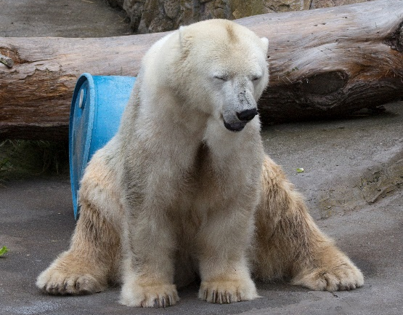 Pike

Snow Leopard – Medical Monitoring
Rigel, a 17-year-old snow leopard, was diagnosed with high blood pressure during a routine life stage work up. He was started on medication for the condition following the exam. The veterinary staff explained that the only way to know if he was on the correct medication dose was to monitor his awake blood pressure on a regular basis. The animal already had a training history of voluntary medical behaviors. He was trained for voluntary weights, injections, and blood draw from his tail. With this solid foundation of training, we were able to train him to allow us to obtain regular blood pressure readings using a blood pressure cuff on his tail. The new behavior was conditioned in approximately one month. His existing repertoire of voluntary medical behaviors helped us train the new behavior in the short time frame. All of his husbandry behaviors combined contributed to his increased longevity and positive quality of life. Without training most of the options we utilized for diagnosis and treatment would not have been available. When he passed at 20 years old, he was the oldest living snow leopard in any U.S. AZA institution.
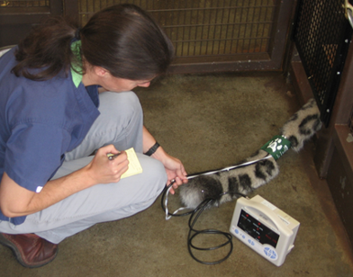 Rigel

Dolphin – Kidney Disease and Fluids
Stormy, an ageing female dolphin suffering from kidney disease, needed fresh water multiple times a day. Dolphins do not drink water naturally so there was a need to train her to accept fluids from her care team voluntarily. I capitalized on her established behaviors to teach her to receive fresh water voluntarily in multiple ways. She was already trained to allow gastric sample collection so conditioning her to allow us to pour water through the tube was an easy behavior addition. We gave her large amounts of water by attaching a funnel to the gastric tube once it was passed to her stomach. We would also give her smaller amounts of water using thin aquarium tubing attached to a 100 ML syringe. The tube was passed a short distance past the back of her tongue and water was given multiple times throughout a feed. In addition to the water, she learned to eat unflavored Jell-O. This added to her hydration and over time became an additional reinforcer. Because dolphins swallow their food whole, the behaviors were not irritating and were easy to use on a daily basis.
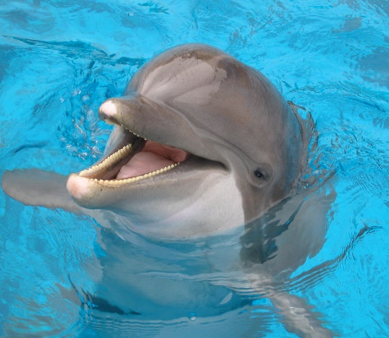 Stormy

Domestic Sheep – Loss of Eyesight and Auditory Target Training
Hazel, an elderly female sheep, lost her eyesight and was unable to navigate her environment without difficulty. When shifting her to different locations in her environment she would regularly run into fencing. Shifting was necessary for daily husbandry and for keeping her with her social group. To help her navigate we taught her to follow an audio jingle bells sound using classical conditioning. We then attached the bells to a feed dish and taught her to follow the moving sound for short distances. Through successive approximations, we slowly increased the distance she followed the bells before receiving reinforcement. This very simple training allowed us to help her safely navigate and shift without negative incidents. Her confidence and welfare improved in a short amount of time with an easily achievable behavior.
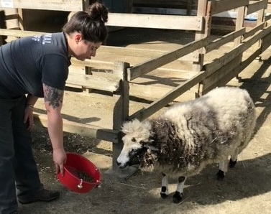 Hazel

Sulphur Crested Cockatoo – Voluntary sedation
Cici, a 46-year-old Sulphur Crested Cockatoo who was diagnosed with an idiopathic epilepsy, experienced seizures at times when startled or stressed. He was due for a routine health exam that would include radiographs, bloodwork, and a re-check of a mass on his abdomen, but restraining him to administer anesthetics was not an option as the stress was likely to trigger a seizure. Staff decided that the best course of action would be to train him for a voluntary sedation via intranasal administration of midazolam and butorphanol. The training plan included a voluntary passive restraint with a towel and the simultaneous insertion of a syringe into both nares. The towel behavior was a safety precaution in case the bird flipped backwards or shook his head. The trainers draped a towel over the bird’s back and applied gentle pressure with their hands to support him. The syringes would administer the sedation drugs. During the training the bird was conditioned to hold for both air and moisture coming through the syringes. On the day of his procedure, staff dispensed 0.25 mls of liquid medication into each nare successfully. The towel was removed; the bird crated voluntarily, and was transported to the hospital. At approximately 7 minutes, post administration of the midazolam and butorphanol the bird was recumbent. His full exam and transport were conducted without any negative incidents or stress.

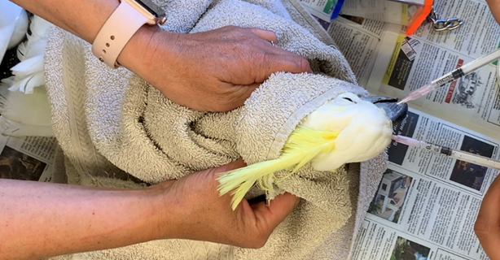 Cici

Teaching our animals to participate in their own health care is beneficial to the animals and their human team of caregivers. Utilizing science based, positive teaching methods we are able to reduce stress and increase welfare by providing animals more choice and control. In addition, we improve safety for animals and humans and strengthen the human animal relationships. Voluntary participation by the animals provides us increased options for diagnostics and treatments throughout their life that would not be possible without co-operative behaviors. The increased health care options often lead to increased longevity and more importantly an improved quality of life.
Many thanks to everyone for your efforts to teach our animals life skills that will support them throughout their lives.

